insert into visits (visit_id, visit_date) values (101, to_date('05061992', 'MMDDYYYY'));  
insert into visits (visit_id, visit_date) values (102, to_date('01072001', 'MMDDYYYY'));  
insert into visits (visit_id, visit_date) values (103, to_date('12062007', 'MMDDYYYY'));  
insert into visits (visit_id, visit_date) values (104, to_date('04042011', 'MMDDYYYY'));  
insert into visits (visit_id, visit_date) values (105, to_date('08052014', 'MMDDYYYY'));  
insert into visits (visit_id, visit_date) values (106, to_date('03042014', 'MMDDYYYY'));  
insert into visits (visit_id, visit_date) values (107, to_date('10252014', 'MMDDYYYY'));  
insert into visits (visit_id, visit_date) values (108, to_date('11021014', 'MMDDYYYY'));  
insert into visits (visit_id, visit_date) values (109, to_date('01022015', 'MMDDYYYY'));  
insert into visits (visit_id, visit_date) values (110, to_date('02032015', 'MMDDYYYY'));  
insert into visits (visit_id, visit_date) values (111, to_date('04092015', 'MMDDYYYY'));  
insert into visits (visit_id, visit_date) values (112, to_date('04192015', 'MMDDYYYY'));  
insert into visits (visit_id, visit_date) values (113, to_date('04192015', 'MMDDYYYY'));  
insert into visits (visit_id, visit_date) values (114, to_date('05172015', 'MMDDYYYY'));  
insert into visits (visit_id, visit_date) values (115, to_date('06182015', 'MMDDYYYY'));

insert into staff (employee_id, data_hired, first_name, middle_name, last_name) values ('A345231', to_date('02252013', 'MMDDYYYY'),'Joyce', '', 'Mara');  
insert into staff (employee_id, data_hired, first_name, middle_name, last_name) values ('A666529', to_date('01112015', 'MMDDYYYY'),'Dana', '', 'Chen');  
insert into staff (employee_id, data_hired, first_name, middle_name, last_name) values ('A220354', to_date('02112012', 'MMDDYYYY'),'Maria', 'CC', 'Myles');  
insert into staff (employee_id, data_hired, first_name, middle_name, last_name) values ('A220355', to_date('06142014', 'MMDDYYYY'),'Amy', '', 'Smith');  
insert into staff (employee_id, data_hired, first_name, middle_name, last_name) values ('A220356', to_date('03152014', 'MMDDYYYY'),'Ted', '', 'Parker');

PHYSICIAN  
insert into physicians (employee_id, certification, other_Certification, speciality) values ( 'A666529','CA99d21-CARD', 'FARC','Cardiologist');  
insert into physicians (employee_id, certification, other_Certification, speciality) values ( 'A220354','NY35381-M','','Internal Medicine');  
insert into physicians (employee_id, certification, other_Certification, speciality) values ( 'A220355','NY35123-M', 'FARC','Internal Medicine');  
insert into physicians (employee_id, certification, other_Certification, speciality) values ( 'A220356','NY35399-M', '','Cardiologist');

insert into staff (employee_id, data_hired, first_name, middle_name, last_name) values ('A345231', to_date('02252013', 'MMDDYYYY'),'Joyce', '', 'Mara');  
insert into staff (employee_id, data_hired, first_name, middle_name, last_name) values ('A543522', to_date('03022013', 'MMDDYYYY'),'Janice', '', 'May');  
insert into staff (employee_id, data_hired, first_name, middle_name, last_name) values ('A865638', to_date('04062011', 'MMDDYYYY'),'Anna', '', 'Blunt');  
insert into staff (employee_id, data_hired, first_name, middle_name, last_name) values ('A744352', to_date('03062012', 'MMDDYYYY'),'Bliss', '', 'Gray');  
insert into staff (employee_id, data_hired, first_name, middle_name, last_name) values ('A546632', to_date('02052001', 'MMDDYYYY'),'Leane', '', 'Marco');

NURSE  
insert into nurses(employee_id, certification) values ('A345231', 'NYS1133');  
insert into nurses(employee_id, certification) values ('A543522', 'NYS1387');  
insert into nurses(employee_id, certification) values ('A865638', 'NYS1133');  
insert into nurses(employee_id, certification) values ('A744352', 'NYS7565');  
insert into nurses(employee_id, certification) values ('A546632', 'NYS8833');

insert into staff (employee_id, data_hired, first_name, middle_name, last_name) values ('A769355', to_date('01032005', 'MMDDYYYY'),'Guy', 'James', 'Fury');  
insert into staff (employee_id, data_hired, first_name, middle_name, last_name) values ('A096748', to_date('05062009', 'MMDDYYYY'),'Pilo', '', 'Filo');  
insert into technologists(employee_id, certification, title) values ('A769355', 'NYS6544', 'Blood-Lab Analyst');  
insert into technologists(employee_id, certification, title) values ('A096748', 'NYS7667', 'X-Ray Technicians');

insert into staff (employee_id, data_hired, first_name, middle_name, last_name) values ('A957735', to_date('04062001', 'MMDDYYYY'), 'Opal', 'H', 'Ray');  
insert into administrative_staff (employee_id, title) values ( 'A957735', 'Manager');

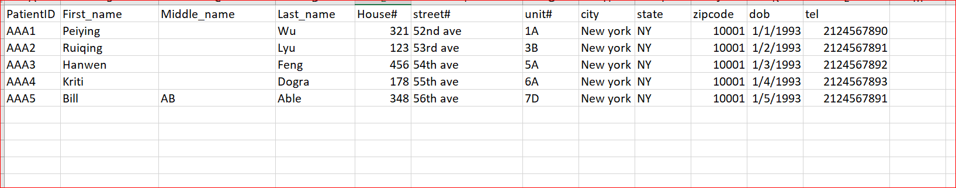

insert into patient(patient_id, first_name, middle_name, last_name, house_num, street_name, unit_num, city, st, zipcode, doB, tel)  
values('AAA1', 'Peiying', '', 'Wu', '321', '52nd ave', '1A', 'New York', 'NY', '10001', to_date('01011993', 'MMDDYYYY'), '2124567890');  
insert into patient(patient_id, first_name, middle_name, last_name, house_num, street_name, unit_num, city, st, zipcode, doB, tel)  
values('RSD9', 'Kriti', '', 'Dogra', '330', 'E 43rd Ave', 'G-73', 'New York', 'NY', '10016', to_date('06031993', 'MMDDYYYY'), '2066086342');  
insert into patient(patient_id, first_name, middle_name, last_name, house_num, street_name, unit_num, city, st, zipcode, doB, tel)  
values('AAA3', 'Ruiqing', '', 'Lyu', '321', '52nd ave', '2B', 'New York', 'NY', '10012', to_date('01011995', 'MMDDYYYY'), '2124567811');  
insert into patient(patient_id, first_name, middle_name, last_name, house_num, street_name, unit_num, city, st, zipcode, doB, tel)  
values('AAA2', 'Hanwen', '', 'Feng', '457', '11nd ave', '1B', 'New York', 'NY', '10012', to_date('01111996', 'MMDDYYYY'), '2123456780');  
insert into patient(patient_id, first_name, middle_name, last_name, house_num, street_name, unit_num, city, st, zipcode, doB, tel)  
values('Ars1', 'Bill', '', 'Able', '191', 'York Ave', '19k', 'New York', 'NY', '10018', to_date('09281997', 'MMDDYYYY'), '2123336666');  
insert into patient(patient_id, first_name, middle_name, last_name, house_num, street_name, unit_num, city, st, zipcode, doB, tel)  
values('DRM6', 'John', '', 'Doe', '9', 'Sycamore', '', 'Fort Myers', 'NJ', '00001', to_date('11301992', 'MMDDYYYY'), '2010001111');

DRUG LIST:

374   
631   
231   
654   
103   
432

insert into prescription (times_per_day, num_days, drug_list_drug_id, visits_visit_id, order_by) values ('3','7','374','101','A666529');

insert into prescription (times_per_day, num_days, drug_list_drug_id, visits_visit_id, order_by) values ('2','10','631','111','');

insert into prescription (times_per_day, num_days, drug_list_drug_id, visits_visit_id, order_by) values ('2','6','231','106','A345231');

INSERT INTO

INSERT INTO Visit_Details( Visits_Visit_ID, Nurses_Employee_ID, Patient_Patient_ID ,Physicians_Employee_ID, Temperature,Weight,Blood_Pressure,Nurse_Notes, Other_Instructions)   
values('101','A345231','AAA1','A666529','105','163.35','120/80','Patient has a headache','')

('115','A345231','DRM6','A666529','103','130','100/79','Patient has a headache','Schedule a follow-up visit in 1 days')

('114','A543522','DRM6','A220354','111','130','100/79','Patient has a headache','Schedule a follow-up visit in 1 days')

('113','A345231','DRM6','A220354','94','130','100/79','Patient has a headache','Schedule a follow-up visit in 1 days')

('112','A345231','AAA1','A666529','103','130','100/79','Patient has a headache','Schedule a follow-up visit in 1 days')

('111','A744352','AAA1','','103','130','100/79','Patient has a headache','Schedule a follow-up visit in 1 days')

('110','A865638','AAA1','A220355','103','130','100/79','Patient has a headache','Schedule a follow-up visit in 1 days')

('109','A865638','AAA1','','103','130','100/79','Patient has a headache','Schedule a follow-up visit in 1 days')

('108','A543522','AAA2','A666529','102','130','100/79','Patient has a headache','Schedule a follow-up visit in 1 days')  
('107','A744352','AAA3','','102','130','100/79','Patient has a headache','Schedule a follow-up visit in 1 days')  
('106','A345231','AAA3','A220355','102','130','100/79','Patient has a headache','Schedule a follow-up visit in 1 days')  
('105','A546632','RSD9','','102','130','100/79','Patient has a headache','Schedule a follow-up visit in 1 days')

insert into patient(patient_id, first_name, middle_name, last_name, house_num, street_name, unit_num, city, state, zipcode, doB, tel) values

SELECT Patient_ID, First_Name, Middle_Name, Last_Name

FROM Patient

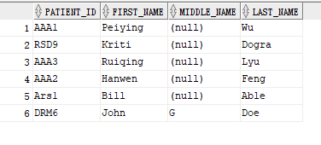

SELECT P.Patient_ID, P.First_Name, P.Middle_Name, P.Last_Name, COUNT (VD.Visits_Visit_ID) AS Num_Visits  
FROM Patient P, Visit_Details VD  
WHERE P.Patient_ID = VD.Patient_Patient_ID  
GROUP BY P.Patient_ID, P.First_Name, P.Middle_Name, P.Last_Name

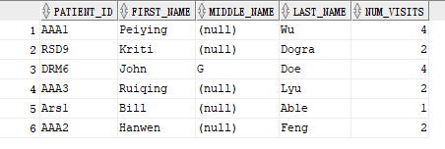

SELECT Drug_list_Drug_ID  
FROM(SELECT Drug_list_Drug_ID, RANK () OVER (ORDER BY Time DESC) AS rnk  
FROM (SELECT Drug_list_Drug_ID, COUNT (Drug_list_Drug_ID) AS Time  
FROM Prescription  
GROUP BY Drug_list_Drug_ID))  
WHERE rnk = '1';

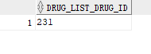

SELECT Nurses_Employee_ID, COUNT (Visits_Visit_ID) as Num_Visits  
FROM Visit_Details  
GROUP BY Nurses_Employee_ID

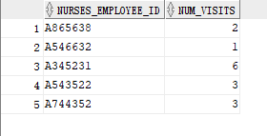

SELECT DISTINCT P.Patient_ID, VD.Physicians_Employee_ID  
From Patient P  
LEFT OUTER JOIN Visit_Details VD  
ON P.Patient_ID = VD.Patient_Patient_ID

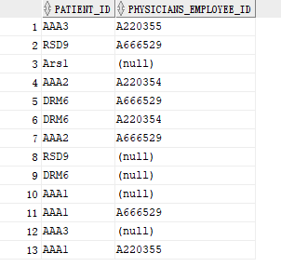

select * from Visit_Details  
  
SELECT P.Patient_ID, P.First_Name, P.Middle_Name, P.Last_Name, COUNT (VD.Visits_Visit_ID) AS Num_Visits  
FROM Patient P, Visit_Details VD  
WHERE P.Patient_ID = VD.Patient_Patient_ID  
GROUP BY VD.Patient_Patient_ID  
  
select Patient_Patient_ID, COUNT (Patient_Patient_ID)  
from Visit_Details  
group by Patient_Patient_ID;  
  
  
INSERT INTO Visit_Details ('Visits_Visit_ID', 'Nurses_Employee_ID', 'Patient_Patient_ID','Physicians_Employee_ID','Temperature', 'Weight', 'Blood_Pressure','Nurse_Notes','Other_Instructions')   
values ('101','A345231','AAA1','A666529','105','163.35','120/80','Patient has a headache','');

insert into prescription (times_per_day, num_days, drug_list_drug_id, visits_visit_id, order_by) values ('2','10','631','111','');

insert into prescription (times_per_day, num_days, drug_list_drug_id, visits_visit_id, order_by) values ('2','6','231','106','A345231');

insert into prescription (times_per_day, num_days, drug_list_drug_id, visits_visit_id, order_by) values ('4','8','231','114','A345231');

SELECT Drug_list_Drug_ID

SELECT Drug_list_Drug_ID, RANK () OVER (ORDER BY Time DESC) AS rnk

FROM (SELECT Drug_list_Drug_ID, COUNT (Drug_list_Drug_ID) AS Time

FROM Prescription)

WHERE rnk = ‘1’